**Experiment-4**

**AIM: Working with Docker file to Build and Push Docker Image.**

**Steps:-**

1. **Creating Dockerfile:-**

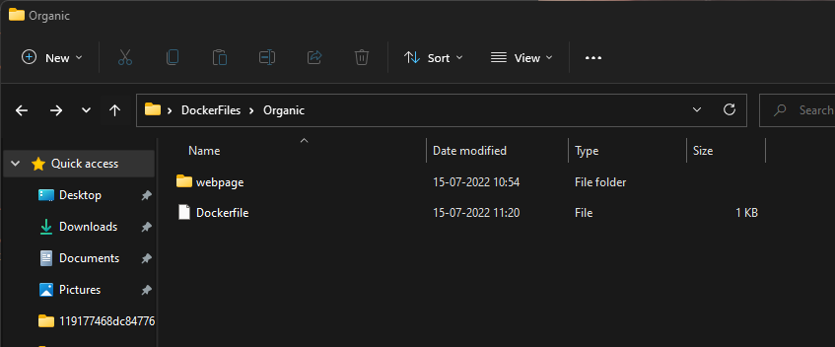

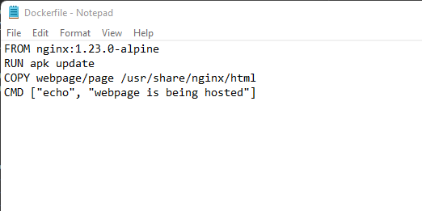

1. **Now we have dockerized the app, we will Build image from Dockerfile:-**

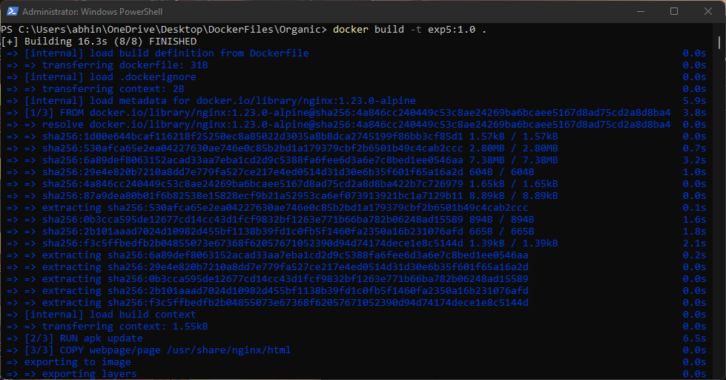

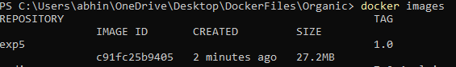

1. **Tagging the image with the remote repository:-**

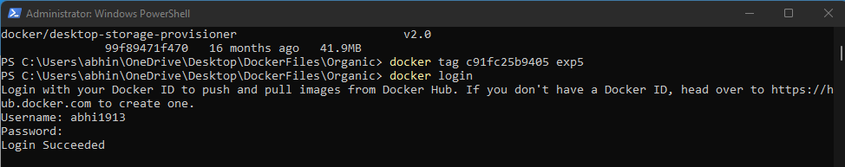

1. **Push the image on Dockerhub:-**

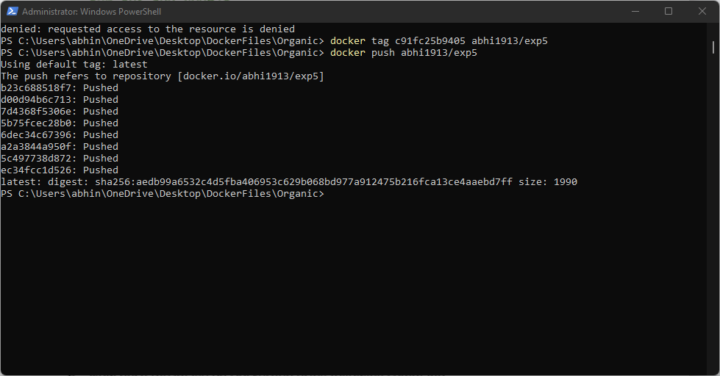

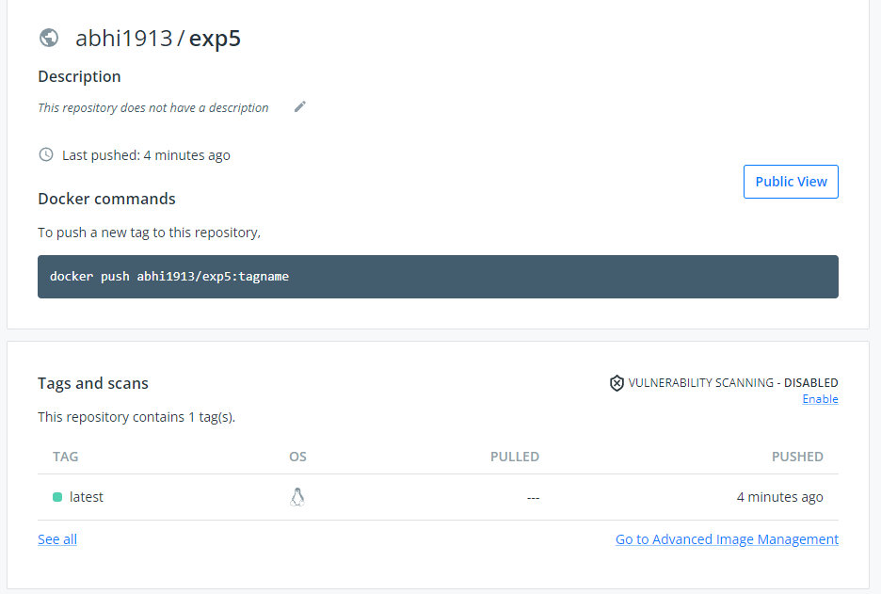

1. **Pull and Run the container of your deployed image on docker hub:-**



